**Largymore Primary School**

**Parent**

**Parent/Carer……………………………………………………………………**

**Child**

**Child’s name………………………………….. Class…………**

**The school will do its best to:**

* Provide an environment which has been risk assessed in response to the COVID-19 infection;
* Adhere to the social distancing rules as set out by the government as much as we reasonably can; sanitise and wash hands as regularly as possible
* Provide a curriculum that meets the needs of your child’s well-being, mental health and academic needs;
* Contact parents/carers if your child displays symptoms of COVID-19;
* Inform you if staff or children in your child’s ‘bubble’ show symptoms of COVID-19 as this will mean you will all need to self-isolate for at least 14 days or until the test comes back negative;
* Continue our clear and consistent approach to rewards and sanctions for children as set out in the Behaviour Policy as well the expectations outlined in this agreement;
* Communicate between home and school through Friday Note, text, SEESAW and the school website.

**I will do my best to:**

* Do my morning routine
* Adhere to the social distancing rules in class and in the playground;
* Tell an adult if I feel unwell;
* Not bring things into school from home, or take things home from school;
* Only use the equipment provided to me by school and no other;
* Only enter and exit the school building from the designated door/gate;
* Follow good respiratory hygiene: coughing and sneezing into elbow or tissue

(CATCH IT-BIN IT-KILL IT);

* Follow good hand hygiene – use soap and water for 20 seconds/ hand sanitiser; or when a member of staff requests it
* Behave well at all times to maintain the safety of myself and others;
* Follow these expectations and know that if I don’t, I will be sent home and will not be able to come back into school until I can be safe.

**To help my child at school, I know and understand that:**

* If my child, or anyone in my household, shows symptoms of COVID-19, I will not send them to school, we will self-isolate for 14 days as a family, I will get them tested and I will let the school know as soon as possible via telephone;
* If my child, or another child in the group, shows symptoms of COVID-19 at school, I will collect my child from school immediately;
* On my commute, and when dropping my child off and picking them up, I will adhere to the 2 metre social distancing rules.
* When dropping off and picking up, I will strictly stick to the school timings for my child;
* My child must not bring any items into school with them or take items home from school;
* My child will have their temperature taken on arrival and during the day if they feel or present as being unwell
* I will need to remind my child about social distancing rules but accept they are difficult to follow and that my child may not always do this successfully
* My child will need to use good respiratory and hand hygiene;
* I will not be allowed into the school without a pre- arranged appointment – make appointments via telephone or email;
* I need to support all staff in their efforts to create an ‘as safe as possible’ environment during this crisis;
* **Read all letters/messages/notices that are sent home**;
* I need to inform the school immediately of any changes to parents/carer and emergency contacts details.
* If my child is deemed unsafe, he/she will be sent home and cannot return to school until they can be safe.

Signed on behalf of the school…………………………………… Date……………………………….

Signed by parent/carer…………………………….…………………….. Date……………………………….

Signed by child………………………….……………………………..…… Date……………………………….

Details of how to get tested can be found on the government

website

<https://www.publichealth.hscni.net/covid-19-coronavirus/testing-and-tracing-covid-19>

**YOUR FAMILY MORNING ROUTINE…**

|  |
| --- |
|  |
| Mum/Dad  “Are you feeling well today?” Yes/No  “Is everyone in your house well today?”  Yes/No.  Symptoms… High Temperature, new continuous cough or runny nose?  YES get ready for school!  Clean jumper/clothes each morning and wash hands before leaving the house. Come straight to school….Do not enter any shops on the way!  NO!! Test required!  Phone NHS helpline and ALL family self-isolate until test result comes back. Please inform us via telephone or email info@largymoreps.sch.ni.co.uk |
|  |
|  |

**COVID-19**

**Home School Protocol**

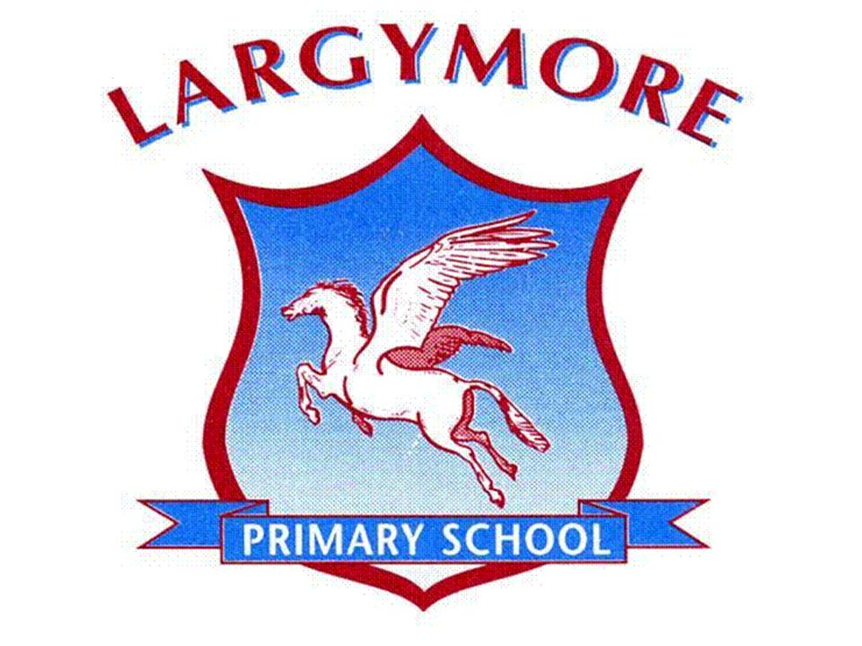

**All in this together…**

**Keep our school as safe a place as it possibly can be!**

**Largymore Primary School**

Hillhall Road

Lisburn

Co. Down

BT27 5BT

028 92663773

gdunlop523@c2kni.net



